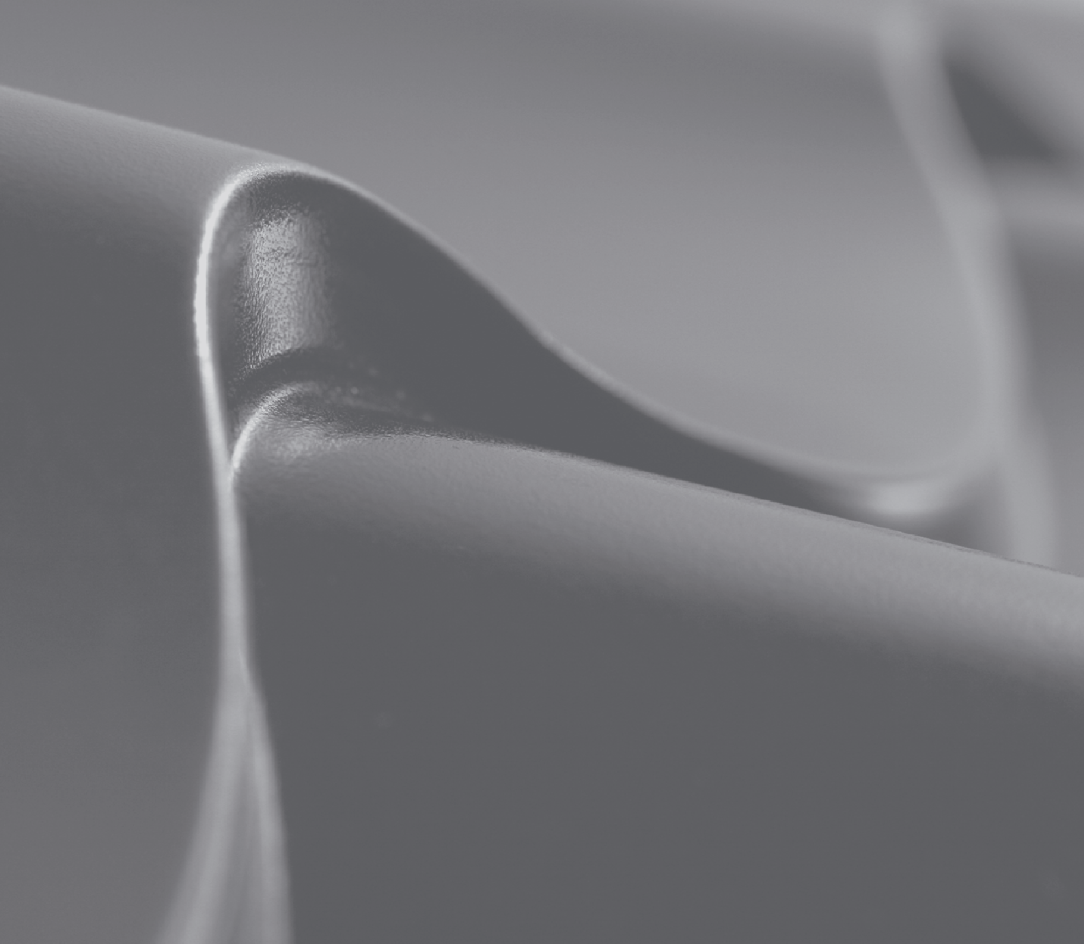

Sheet Metal Working Machinery

Tile Sheet Rollformers, Roofing and Cladding Profile Rollformers, Cut-to-length and Slitting Machinery, Additional Equipment

September 2009

#### 2 Sheet Metal Working Machinery

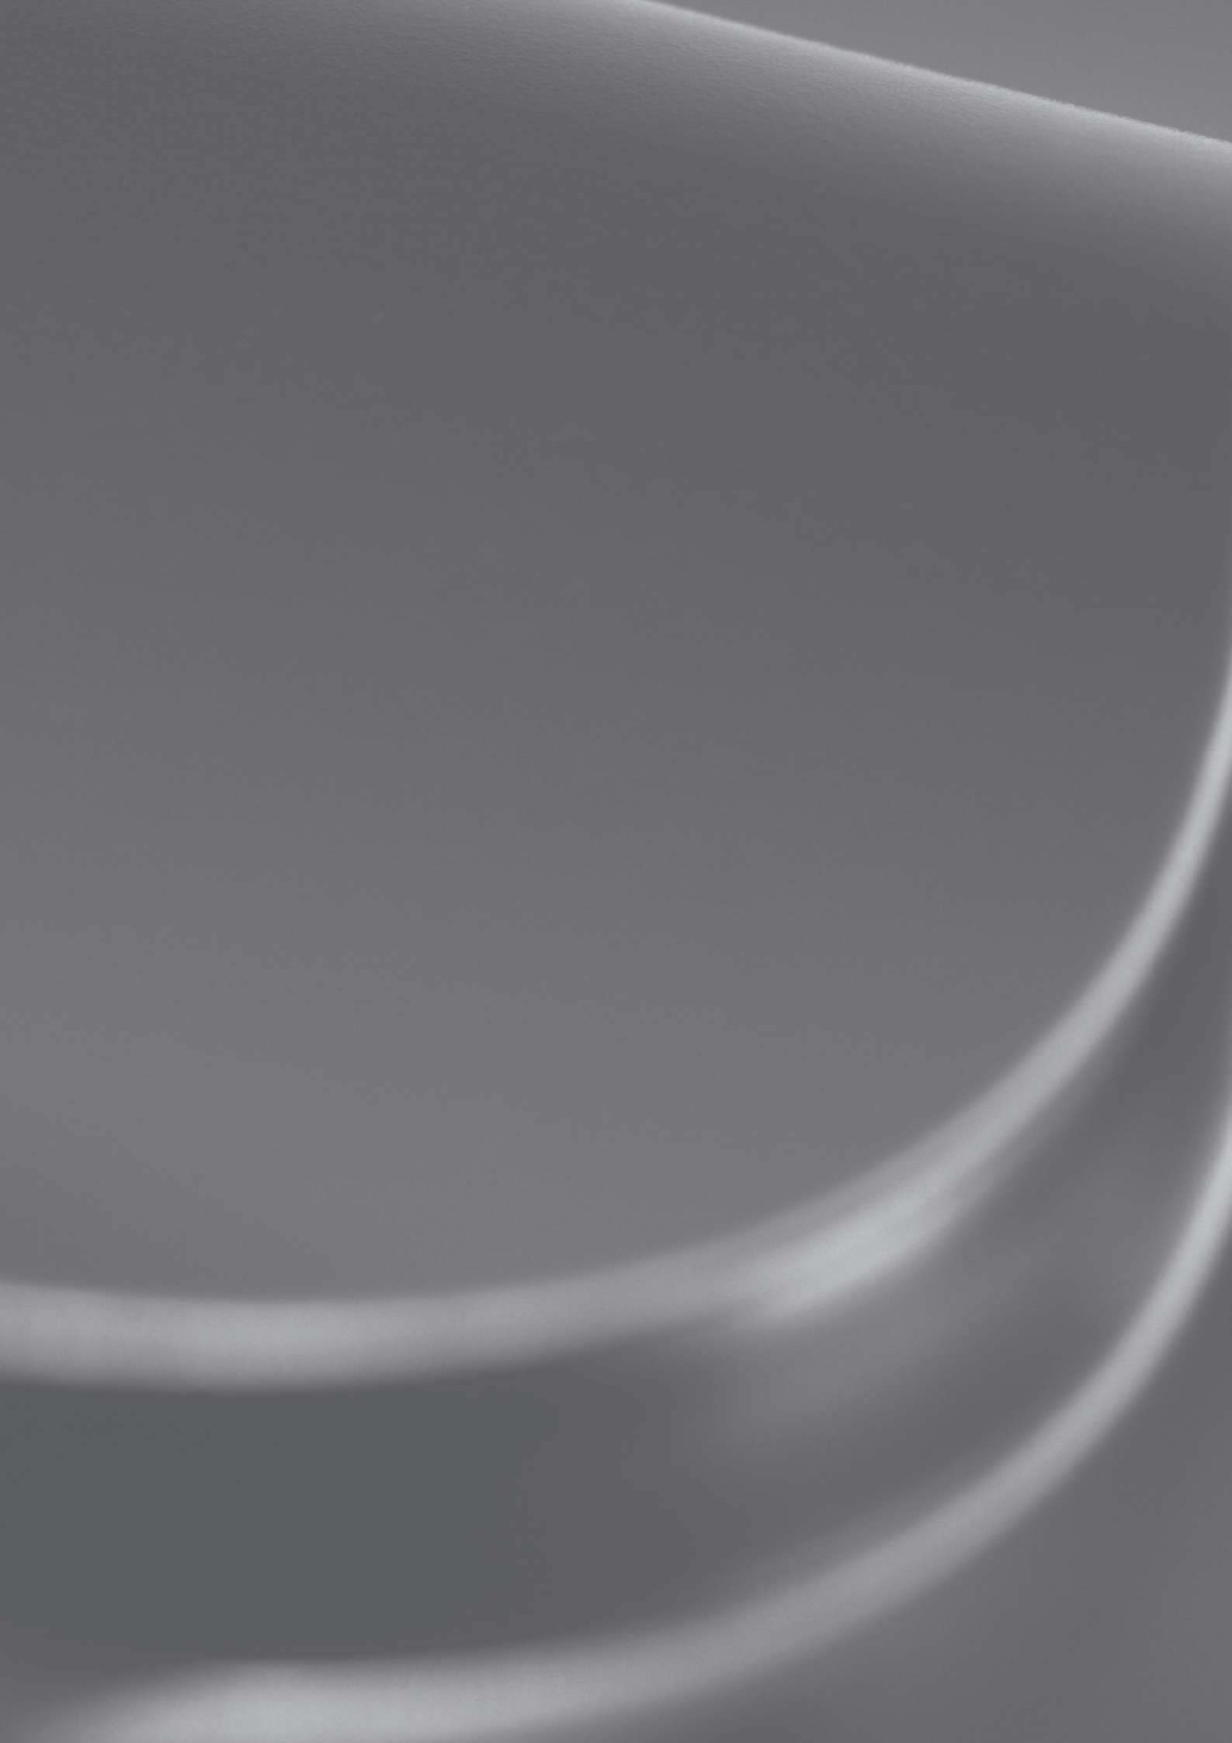

Table of Contents

Introduction 3

Tile Sheet Rollformers

Tile Sheet Production Line 6

Ridge Cap Machine 8

Roofing and Cladding Profile Rollformers

Rollformer for Trapeze Profile 10

Double-deck Rollformer 12

Slate Profile Rollformer 14

Table of Profiles 16

Cut-to-length and Slitting Machinery

Cut-to-length and Slitting Unit 1250 mm / 1.25 mm 18

Cut-to-length and Slitting Unit 1500 mm / 2.0 mm 19

Re-coiler and Felt Brake 20

Additional Equipment

Decoilers 5 to 15 tons 22

Stackers 23

Wrapping Machine 24

Downspout and Elbow Machine 25

Gutter Machines 25

Customised Rollformers for Roofing Accessories 26

Teppolantie 4 FI-90440 Kempele Finland Tel. +358 8 5634 700 Fax +358 8 5208 752 [info@profiilikeskus.fi](mailto:info@profiilikeskus.fi) [www.profiilikeskus.fi](http://www.profiilikeskus.fi/)

Sheet Metal Working Machinery 3



Teppolantie 4 FI-90440 Kempele Finland Tel. +358 8 5634 700 Fax +358 8 5208 752 [info@profiilikeskus.fi](mailto:info@profiilikeskus.fi) [www.profiilikeskus.fi](http://www.profiilikeskus.fi/)

## Introduction

Profiilikeskus Ltd. has been in business over fifteen years and distributes its products world- wide. We offer wide range of expertise and knowledge in both machine and factory design, and in our own roll-forming mill we can test and develop new methods for our customers´ benefit.

Our customer lies at the heart of our philosophy. We are committed to making equipment that makes your business more productive. Our sales and design team takes the time to get a clear picture of your exact needs. Whether it’s a single piece of equipment or a totally new state of the art manufacturing system, we help you clearly set your equipment objec- tives, and then develop systems to meet these objectives.

Your production requirements, unique manufacturing situation and approach to business are all key ingredients in the design of your equipment. We begin with clearly defined plans based on your needs. The tooling and equipment we produce for you is how we keep our promise.

We understand that your customer expects you to meet their deadlines with quality prod- ucts that are on time, that fit right, and that deliver the strength and durability to stand the test of time. We also understand that your business is in a highly competitive environment. The metal construction components you manufacture must do all of this, with quality and efficiency, and at a price your customers can afford.

Starting with our highly trained and experienced sales team, everyone at Profiilikeskus is committed to your needs. This partnership focuses on you and your goals through open lines of communication and service, which is fundamental to our promise.

On-time delivery, increased productivity in your manufacturing process and 100% after- sales commitment – these are not just goals for us – this is the way we do business.

#### 4 Sheet Metal Working Machinery

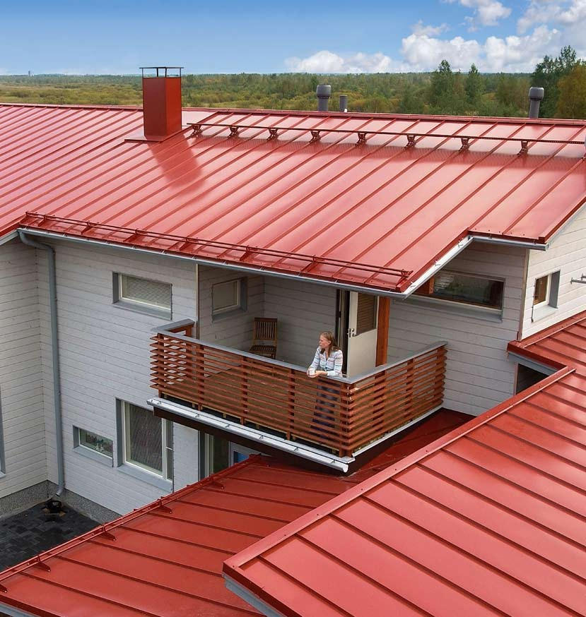

Teppolantie 4 FI-90440 Kempele Finland Tel. +358 8 5634 700 Fax +358 8 5208 752 [info@profiilikeskus.fi](mailto:info@profiilikeskus.fi) [www.profiilikeskus.fi](http://www.profiilikeskus.fi/)

#### Tile Sheet Rollformers 5

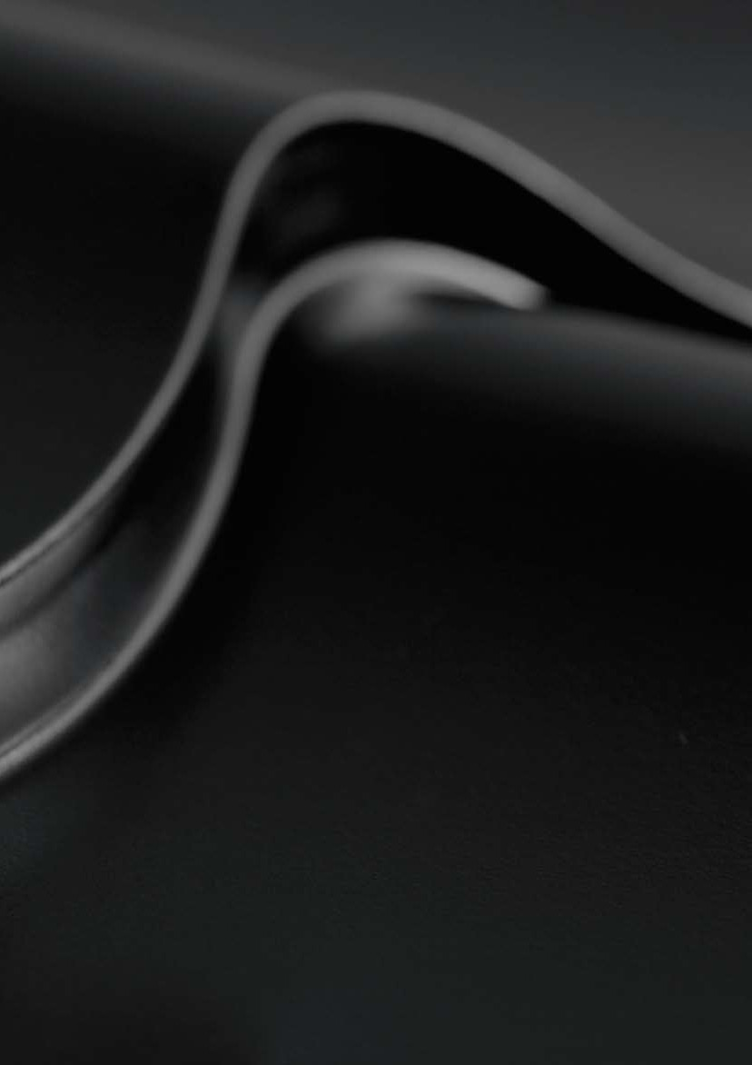

# Tile Sheet Rollformers

Our tile sheet rollforming line meets the production demands of today´s heavy industry.

The rollformer is driven by a powerful electric motor. The press and the post cutter are operated by an 11 kW hydraulic unit. With an efficient production speed of 8 metres per minute you can reach production output of 15 tons in one shift.

An advanced Programmable Logic Controller (PLC) unit is provided with an LCD- monitor and the necessary electrical components for manual and automatic line op- eration. The control unit controls the operations of the roll forming machine, press, cutter and stacker.

Our advanced software enables you to modify the distance between pressings and the length of the eaves section. Up to 10 different lengths and 1000 pieces can be programmed for each production set. With the latest pressing tool it is possible to press various step heights (minimum 14 mm / maximum 25 mm) just by placing ad- ditional plates under the tool set. This takes approximately 5 minutes.

These features make our Tile Sheet Line highly efficient and user friendly. The pro- cess is fully automated and can easily be operated by one man.

Teppolantie 4 FI-90440 Kempele Finland Tel. +358 8 5634 700 Fax +358 8 5208 752 [info@profiilikeskus.fi](mailto:info@profiilikeskus.fi) [www.profiilikeskus.fi](http://www.profiilikeskus.fi/)

6 Tile Sheet Rollformers

## Tile Sheet Production Line

Profiilikeskus tile sheet rollformers are the product of over 20 years’ experience of designing high-quality rollforming machines for the international market, and simultaneously using our own rollformers to manufacture steel roofing for the demanding needs of our home market in Finland.

* Line includes: rollforming section, press, post-cutter, pre-cutter, automatic stacker, decoiler
* All our machines use the minimum of factory floor space
* Production speed 8 metres per minute (sheet length 6000 mm)., max. output 15 tonnes per shift
* Drive with electrical motor 7.5 kW for 16 chain-driven shaftpairs
* Hydraulic unit 11 kW for the press and post-cutter
* Under lapping side of the sheet has both water channel and capillary groove
* The height of the tile step and the distance for the first pressing at the eaves can also be adjusted

We accept only the most practical design solutions and stan- dards. Operation of the tile sheet rollformer is fully automat- ed and the machine can easily be operated by one person. Advanced software and an easy-to-use user interface allow for fast setting of the rollformer, including the tile length.

### Material Requirements

##### Thickness

0.5 mm

###### Width of strip

1250 mm or for customized width

##### For coated steel Steel quality

DIN EN 10346: S220GD+Z – S320GD+Z

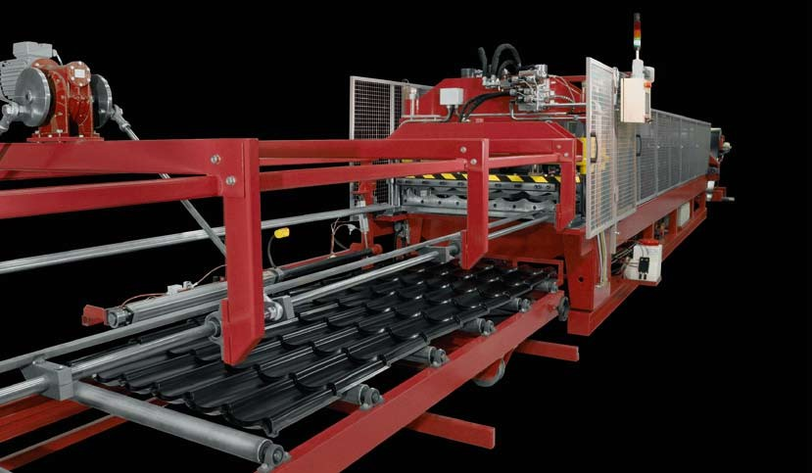

Teppolantie 4 FI-90440 Kempele Finland Tel. +358 8 5634 700 Fax +358 8 5208 752 [info@profiilikeskus.fi](mailto:info@profiilikeskus.fi) [www.profiilikeskus.fi](http://www.profiilikeskus.fi/)

Tile Sheet Rollformers 7

### Profile is asymmetric tile

**Height of proflle** 25 mm

**Step height** from 14 to 25 mm

25 mm

1100 mm

**Total proflle height** from 39 to 50 mm

**Covering width** 1100 mm

183 mm

**Height of proflle** 36 mm

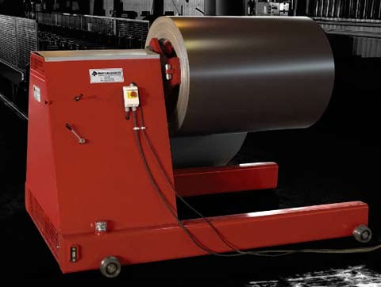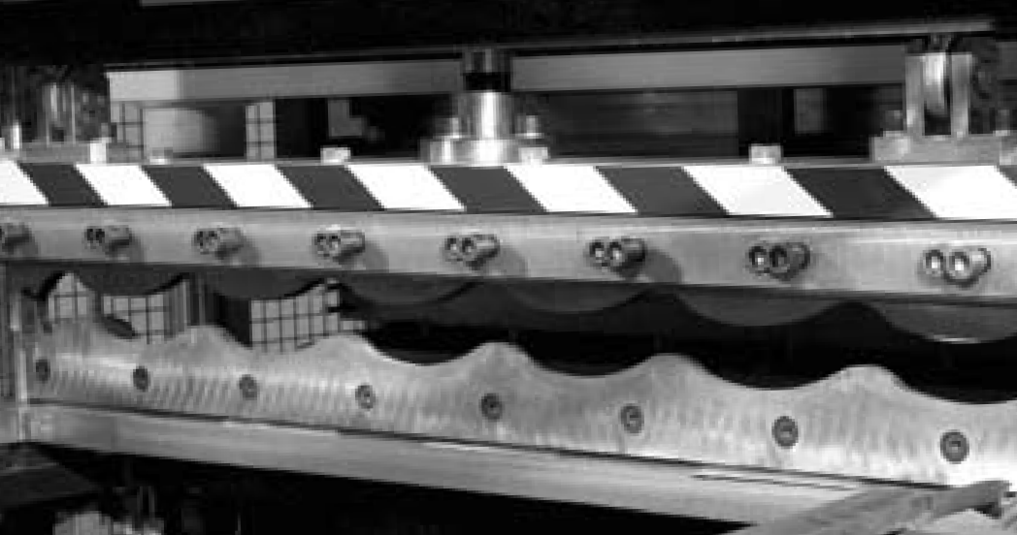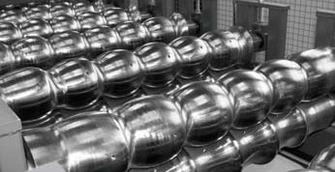

Teppolantie 4 FI-90440 Kempele Finland Tel. +358 8 5634 700 Fax +358 8 5208 752 [info@profiilikeskus.fi](mailto:info@profiilikeskus.fi) [www.profiilikeskus.fi](http://www.profiilikeskus.fi/)

**Step height** 16 to 20 mm

**Total proflle height** 52 to 56 mm

**Covering width** 1065 mm

* Decoiler 7.5 tn, coil ID 508–610 mm
* Expansion with wedge mechanism
* Hydraulic wheeling and tightening of coil

213 mm

36 mm

1065 mm

The press tooling is made from tool steel 100MnCrW4. The movement of the pressing tool is controlled by two hydraulic cylinders, with a working pressure of 160 bar.

The cutting blades of the post cutter are made of hard- ened tool steel and are 16 mm thick. The blades have, therefore, a long service life and can be sharpened several times. The rollformer, press and cutter can be steered from the control unit either in manual or automatic drive. The cutter is a guillotine type eccentric cutter and is oper- ated by hydraulic motor. The press and cutter are station- ary (not flying).

Automatic stacker 6 m and motorized roller line with side movement 8 m. Pneumatically operated stacking arm.

8 Tile Sheet Rollformers

## Ridge Cap Machine

### An elegant half round ridge cap is needed to complete the finishing touch to the Tile sheet roof.

Our compact ridge cap rollformer is provided with neces- sary electrical components for manual and automatic run- ning of the line. Preset the number of pressings in a piece into the parameters and all you need to enter in produc- tion mode is the piece amount.

##### Pneumatic spraying system

**Width of strip**

416 mm +/- 10mm

##### Thickness

0.5 - 0.6 mm

##### Pre-coated steel

**Electrical drive and Hydraulic press and cutter**

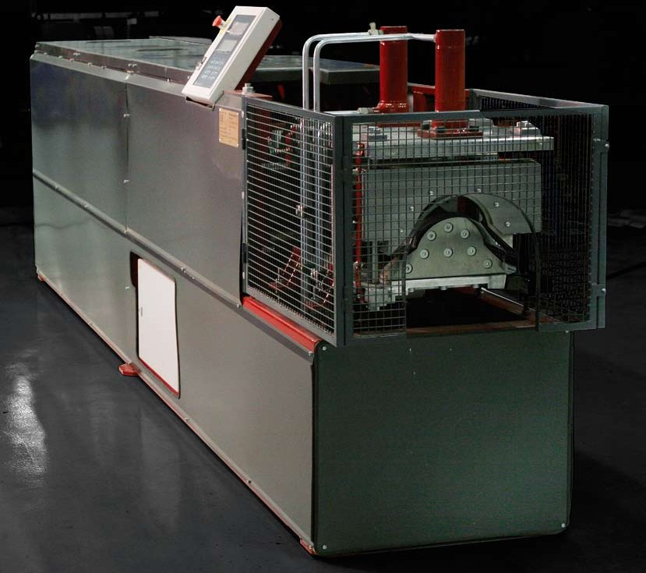

Teppolantie 4 FI-90440 Kempele Finland Tel. +358 8 5634 700 Fax +358 8 5208 752 [info@profiilikeskus.fi](mailto:info@profiilikeskus.fi) [www.profiilikeskus.fi](http://www.profiilikeskus.fi/)

#### Roofing and Cladding Profile Rollformers 9



# Roofing and Cladding Profile Rollformers

We supply and manufacture Roofing and Cladding Profile Rollformers, including Trapeze Rollformers, Double-deck Rollformers and Slate Profile Rollformers for small to large-scale production volumes. The main differences are in the machine construc- tion and production speed.

##### Light machinery

The frame in our economic trapeze rollformer is solid and the shafts are attached to the frame. This enables you to rollform raw materials to thicknesses of between

0.45 – 0.6 mm. Production speed varies from 15 to 20 metres per minute.

A user friendly control unit is provided with an LED-monitor and the necessary electrical components for manual and automatic line operation. This unit controls the operation of the rollforming machine and the cutter. Up to 8 different lengths and 999 pieces per length can be programmed.

##### Heavy-duty machinery

In our heavy-duty machinery the shafts are attached to adjustable stations, enabling you to rollform raw material up to a thickness of 0.9 mm. An efficient production speed of 40 metres per minute guarantees maximum output. When the rollformer is equipped with a pre-cutter there is no waste left over when changing the coil.

An advanced Programmable Logic Controller (PLC) control unit is provided with an LCD-monitor and the necessary electrical components for manual and automatic line operation. This unit controls the operation of the rollforming machine, cutter and stacker. Up to 10 different lengths and 1000 pieces can be programmed.

All of our machinery meets European CE - safety requirements. Parts used in our control units are universal and easily obtainable worldwide.

Teppolantie 4 FI-90440 Kempele Finland Tel. +358 8 5634 700 Fax +358 8 5208 752 [info@profiilikeskus.fi](mailto:info@profiilikeskus.fi) [www.profiilikeskus.fi](http://www.profiilikeskus.fi/)

## Rollformer for Trapeze Profile

Profiilikeskus Trapeze and Corrugated Profile Rollform- ers provide dependable production solutions for both low and high volume sheet metal manufacturing. All the structures and components, such as cutters and drives, utilize only the most practical and fully-tested solutions.

The operation of our trapeze and corrugated profile rollformers is fully automated and the machines can eas- ily be operated by one person. Advanced software and an easy-to-use user interface allow for fast setting of the machines.

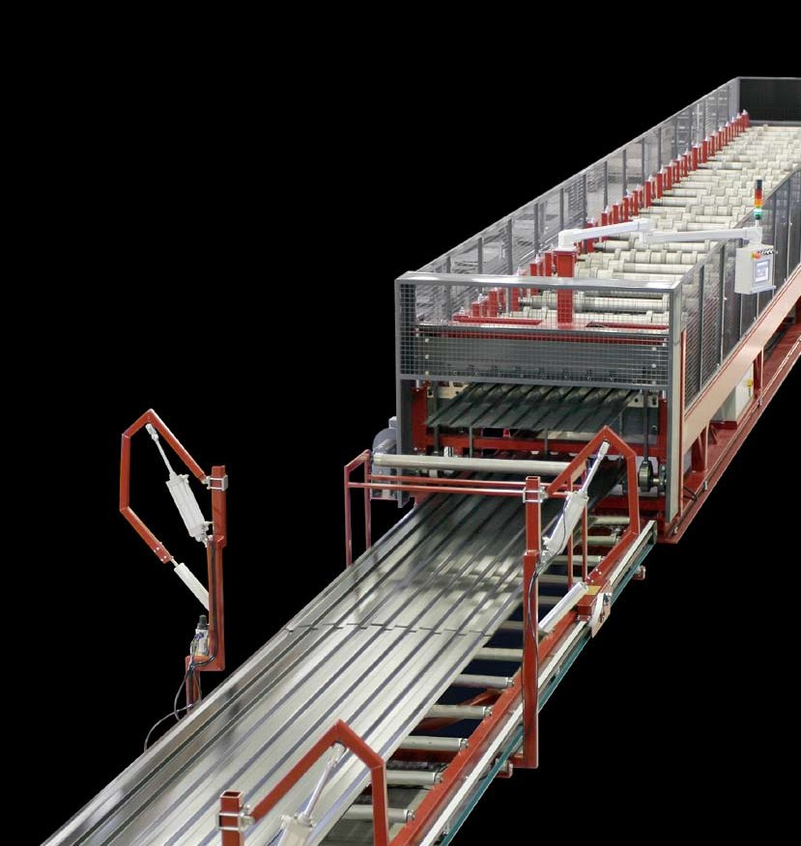

We are always ready to tailor and optimize our products to meet the indi- vidual requirements of your operations. This also includes several options for stackers and decoilers.

* Frame is a welded construction and made of heavy duty steel, quality st. 355 E.N. 10025
* Chain driven with electrical motors
* Forming rolls are fine-turned at Ra 0.8 surface and nitrocarburized
* Every forming roll is attached to the shaft by keyway. The spacers between the forming rolls are partly fixed with keyway and partly free rotating. The relevant spac-

ers which are part of the forming process are fitted with bearings

* The forming rolls and spacers form a solid packet. In addition this packet is secured from both ends with axle nuts
* Adjustable stations

Teppolantie 4 FI-90440 Kempele Finland Tel. +358 8 5634 700 Fax +358 8 5208 752 [info@profiilikeskus.fi](mailto:info@profiilikeskus.fi) [www.profiilikeskus.fi](http://www.profiilikeskus.fi/)

### Material Requirements

##### Thickness

0.45 up to 1.25 mm

##### Width of strip

Customized

##### Coatings

Pre-coated and galvanized

##### Steel quality

DIN EN 10346: S220GD+Z – S350GD+Z

**Speed 40 metres/minute excluding cutting time**

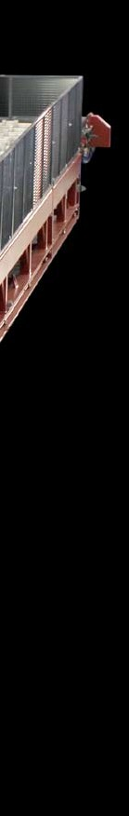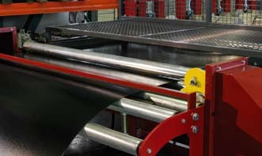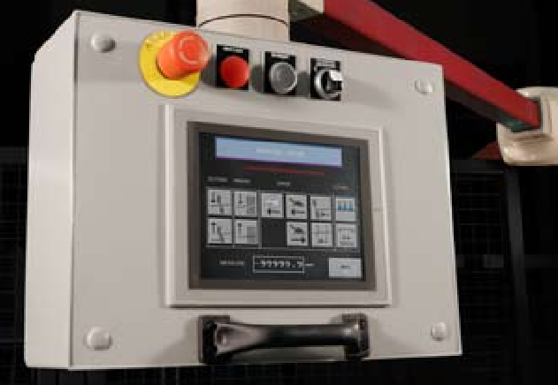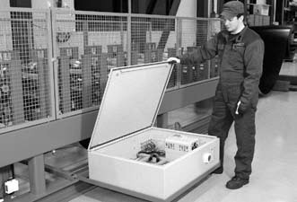

### Pre-cutter, electric

* For cutting the flat sheet automatically when changing the coil
* Control unit calculates the correct cutting point for the very last programmed sheet, stops the roll former and cuts the flat sheet at the entry table before the first stations

All our rollforming machines use the minimum of factory floor space, as electric boxes are conveniently placed under the machine. Where space is severely limited, our double-deck rollformers provide the perfect solution for maximized capacity.

Advanced software and an easy-to-use screen interface allow for fast setting of Profiilikeskus Trapeze Rollformers. By our Pro-C software, customer orders can be electronically trans- ferred from office computer directly into the Rollformer’s interface. Several Rollformers can be connected into the Pro-C system.

Teppolantie 4 FI-90440 Kempele Finland Tel. +358 8 5634 700 Fax +358 8 5208 752 [info@profiilikeskus.fi](mailto:info@profiilikeskus.fi) [www.profiilikeskus.fi](http://www.profiilikeskus.fi/)

## Double-deck Rollformer

If factory space is limiting your company’s prospects for growth, a Profiilikeskus double-deck rollformer offers the best solution to get more out of your premises. Our

double-deck rollformer allows you to manufacture two dif- ferent profiles on one rollformer.

* Rollforming sections for two different profiles, post-cut- ters for the end products, pre-cutter for the flat sheet, automatic stacker.
* Both the lower and upper rollforming sections are driv- en by their own electric motors. Consequently, stress for the drives and axles is minimized, which results in maximised machine reliability.

All the machine functions are controlled through an easy- to-use screen interface. Rubbered draw-in rollers drive the sheet automatically into the rollforming section. Thanks to this, the upper-level-sheet-entry can also be conveniently done at normal working height

* For unloading, the inner part of the dual-frame stacker rises above all the other structures, which enables the safe removal of the completed stack, for example, by a forklift.

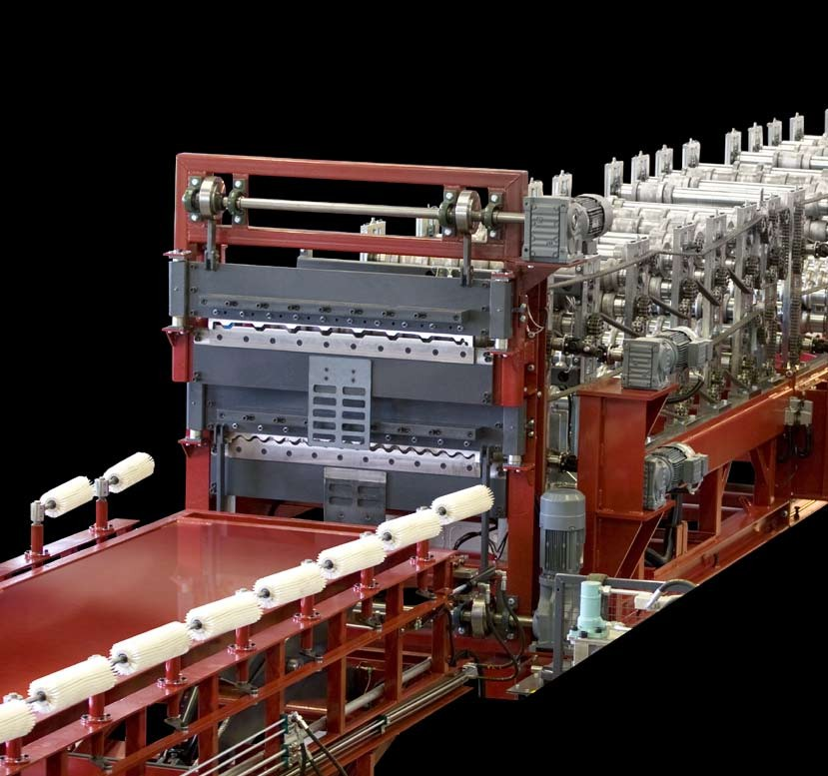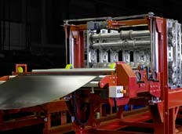

The sheet entry table is hydrauli- cally ascending and descending. The upper-level- sheet-entry can also be conve- niently done at normal working height.

Teppolantie 4 FI-90440 Kempele Finland Tel. +358 8 5634 700 Fax +358 8 5208 752 [info@profiilikeskus.fi](mailto:info@profiilikeskus.fi) [www.profiilikeskus.fi](http://www.profiilikeskus.fi/)

### Material Requirements

##### Thickness

0.45 mm–0.9 mm

##### Width of strip

1250 mm or for customized width

##### Coatings

Pre-coated and galvanized

##### Steel quality

DIN EN 10346: S220GD+Z – S350GD+Z

The rollformer can be steered from the control unit either in manual or automatic drive. Steering and programming are made extremely user-friendly. The machine is controlled from a touchscreen and with switches in the control desk.

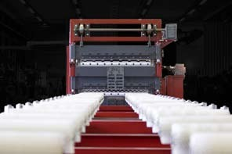

The stacker level is automatically controlled by the machine software. During sheet production, the stacker height is automatically lowered step by step along with the increasing number of completed sheets. As a result, not even the first profile sheets of a stack are ever likely to fall down from a high position, ensuring 100-percent damage-free end products.

The construc- tion of stations allows for easy maintenance access to all the parts of the machine.

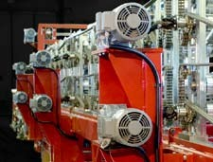

The rollform- ing sections are driven by their own electric motors, which minimizes stress for the drives and axles.

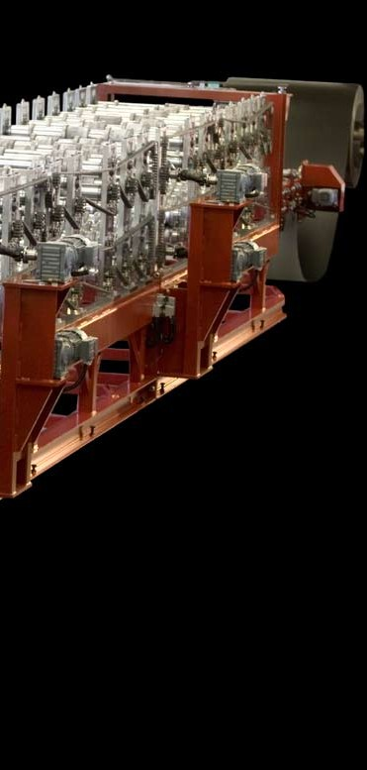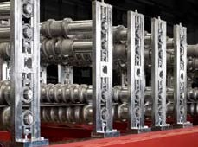

Teppolantie 4 FI-90440 Kempele Finland Tel. +358 8 5634 700 Fax +358 8 5208 752 [info@profiilikeskus.fi](mailto:info@profiilikeskus.fi) [www.profiilikeskus.fi](http://www.profiilikeskus.fi/)

## Slate Profile Rollformer

A Profiilikeskus slate profile rollformer is a completely new innovation. It opens up a fresh opportunity for steel roofing manufacturers to expand their business. The rollformer combines the traditional beauty of a slate roof with all the benefits allowed by modern steel roofing.

Thanks to the careful design of the profile shape, the slate profiles are quick and easy to install and they produce a hundred percent water proof structure. The profiles can be directly installed on roof trusses or rafters.

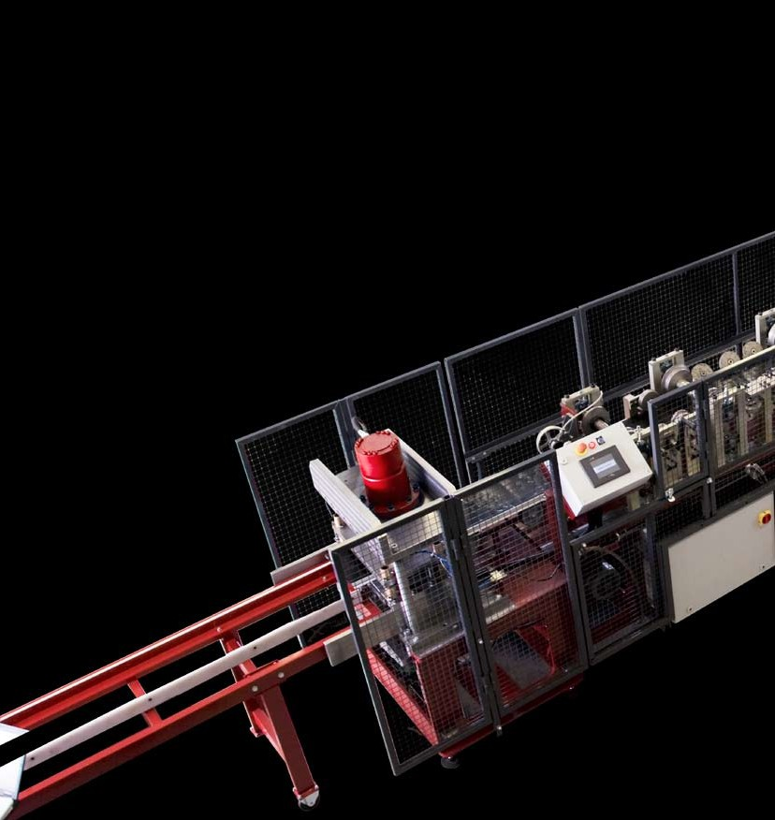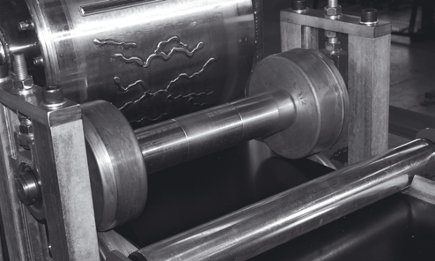

* The rollformer has a fully machined frame including ma- chined stations. This results in extraordinary measure- ment accuracy of profiles and further ensures hundred percent water proof roofing in all conditions
* All the machine controls are available in one spot through an easy-to-use interface screen
* Based on desired profile length, advanced software determines the right cutting point

The slate profile embossing roll has its own motor and hydraulics and the roll is automatically turned off when joint support pieces are being produced.

Teppolantie 4 FI-90440 Kempele Finland Tel. +358 8 5634 700 Fax +358 8 5208 752 [info@profiilikeskus.fi](mailto:info@profiilikeskus.fi) [www.profiilikeskus.fi](http://www.profiilikeskus.fi/)

### Material Requirements

##### Thickness

0.7 mm

##### Width of strip

406 ±5 mm

##### Coatings

Pre-coated sheet

##### Steel quality

DIN EN 10346: S220GD+Z – S320GD+Z

The same rollformer is used to produce the roofing profiles as well as the joint support pieces. Tool change is fast and easy. No other special machines or accessories are needed to deliver state-of-the-art steel profile slate roofs.

The slate profiles are quick and easy to install and they produce a hundred percent water proof structure. The profiles can be directly installed on roof trusses or rafters.

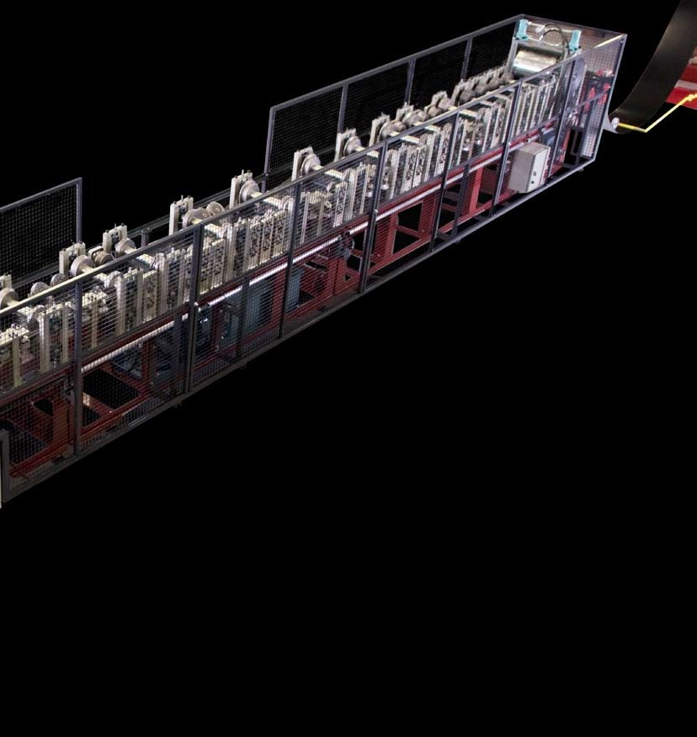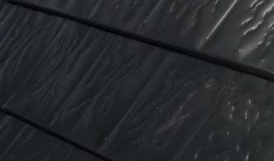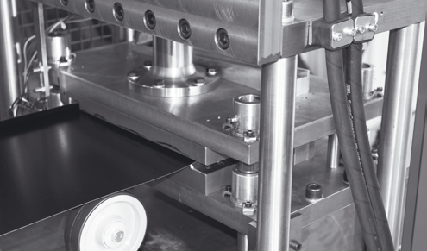

Teppolantie 4 FI-90440 Kempele Finland Tel. +358 8 5634 700 Fax +358 8 5208 752 [info@profiilikeskus.fi](mailto:info@profiilikeskus.fi) [www.profiilikeskus.fi](http://www.profiilikeskus.fi/)



Teppolantie 4 FI-90440 Kempele Finland Tel. +358 8 5634 700 Fax +358 8 5208 752 [info@profiilikeskus.fi](mailto:info@profiilikeskus.fi) [www.profiilikeskus.fi](http://www.profiilikeskus.fi/)

Table of Profiles

|  |  |  |  |  |  |  |  |
| --- | --- | --- | --- | --- | --- | --- | --- |
| **Proflle** | **Strip Thickness** | **Strip Width** | **Crosscut** | | | | |
| **T8/115/1150** | 0.45 – 0.8 mm | 1200,1220,1230,1250 mm | 115 mm 52.5 mm 62.5 mm  8 mm    1150 mm | | | | |
| **T15/164/1150** | 0.45 – 0.8 mm | 1200,1220,1230,1250 mm | 164 mm 104 mm 60 mm 30 mm  15 mm    1150 mm | | | | |
| **T18/76/1064** | 0.45 – 0.8 mm | 1200,1220,1230,1250 mm | 76 mm  18 mm    1064 mm | | | | |
| **T18/137.5/1100** | 0.45 – 0.8 mm | 1200,1220,1230,1250 mm | 137.5 mm 32 mm 77 mm 60.5 mm  18 mm    1100 mm | | | | |
| **T19/76.2/1067** | 0.45 – 0.8 mm | 1200,1220,1230,1250 mm | 76.2 mm  19 mm    1067 mm | | | | |
| **T21/100/1000** | 0.45 – 0.8 mm | 1200,1220,1230,1250 mm | 100 mm 35 mm 65 mm  21 mm    1000 mm | | | | |
| **T25/200/1000** | 0.45 – 0.8 mm | 1200,1220,1230,1250 mm | 200 mm 26 mm  25 mm      1000 mm | | | | |
| **T25/280/840** | 0.45 – 0.8 mm | 1000 mm | 280 mm 40 mm  25 mm      840 mm | | | | |
| **T27/190/950** | 0.45 – 0.8 mm | 1200,1220,1230,1250 mm | 190 mm 26 mm  27 mm      950 mm | | | | |
| **T34/150/900** | 0.45 – 0.9 mm | 1200,1220,1230,1250 mm | 150 mm 18 mm 80 mm 70 mm  34 mm  900 mm | | | | |
| **T34/207/1035** | 0.45 – 0.9 mm | 1200,1220,1230,1250 mm | 207 mm 40 mm 110 mm  34 mm  1035 mm | | | | |
| **T35/200/1000** | 0.45 – 0.9 mm | 1200,1220,1230,1250 mm | 200 mm 38 mm 127 mm 73 mm  35 mm  1000 mm | | | | |
| **T35/207/1035** | 0.45 – 0.9 mm | 1200,1220,1230,1250 mm | 207 mm 40 mm  35 mm  1035 mm | | | | |
| **T44/150/900** | 0.45 – 0.9 mm | 1250 mm | 150 mm 30 mm 60 mm 90 mm    44 mm    900 mm | | | | |
| **T57/187.5/750** | 0.45 – 0.9 mm | 1250 mm | 187.5 mm 187.5 mm 44 mm  57 mm  750 mm | | | | |
| **T60/211.5/845** | 0.45 – 0.9 mm | 1250 mm | 211.5 mm 50 mm 122 mm 89.5 mm  60 mm  845 mm | | | | |
| **T75/187.5/750** | 0.75 – 1.25 mm | 1250 mm | 187.5 mm 92 mm 50 mm  75 mm  750 mm | | | | |
| **T83/280/1120** | 0.75 – 1.25 mm | 1500 mm | 83 mm | 280 mm 240 mm | |  | |
|  | 1120 mm |  |  |
| **T112.5/250/750** | 0.75 – 1.25 mm | 1250 mm | 56 mm  112.5 mm  89 mm  250 mm 750 mm | | | | |
| **T135/310/930** | 0.75 – 1.25 mm | 1500 mm | 135 mm  310 mm  930 mm | | | | |
| **T150/280/840** | 0.75 – 1.25 mm | 1500 mm | 280 mm 161 mm  40 mm  153 mm  119 mm  241 mm  840 mm | | | | |

#### Cut-to-length and Slitting Machinery 17



# Cut-to-length and Slitting Machinery

Our reliable and cost-efficient Cut-to-length and Slitting machines are manufac- tured for material width of 1250 mm / thickness 1.25 mm and for a width of 1500 mm / thickness 2 mm. Both Cut-to-length and Slitting sections are combined in one machine.

Teppolantie 4 FI-90440 Kempele Finland Tel. +358 8 5634 700 Fax +358 8 5208 752 [info@profiilikeskus.fi](mailto:info@profiilikeskus.fi) [www.profiilikeskus.fi](http://www.profiilikeskus.fi/)

## Cut-to-length and Slitting Unit 1250 mm / 1.25 mm

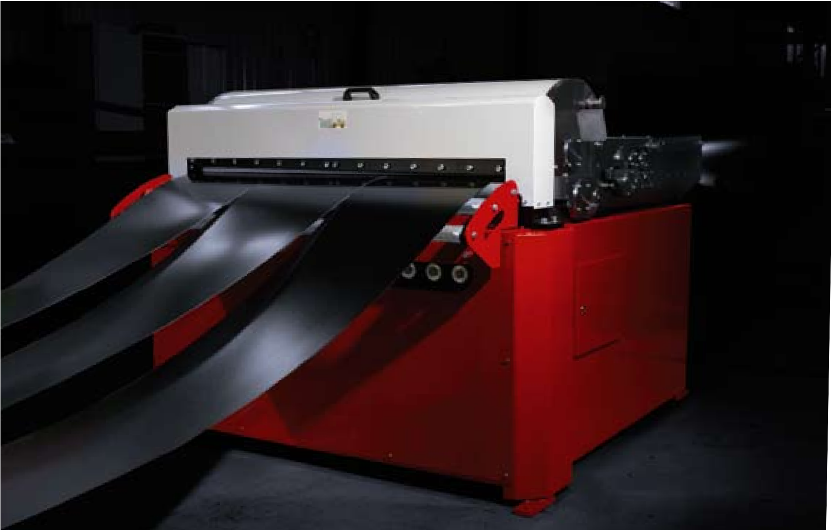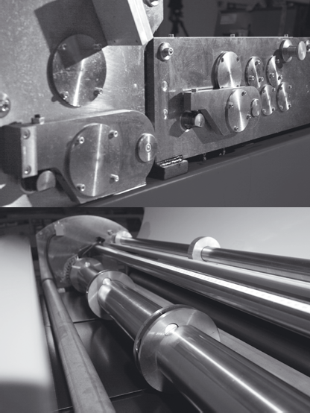

A specially designer stacker is available for our cut-to-length and slitting units. The stacker ensures efficient operation and damage-free sheet surfaces in all production conditions.

* Electrically operated 5 kW
* Shear for cut-to-length sheets and slitting unit with 5 blade pairs
* Max. strip width 1250 mm
* Strip thickness: steel 0.5–1.25 mm
  + Strip thickness 0.5–0.6 mm, slitting with max. 8 blade pairs
  + Strip thickness 0.7–0.9 mm, slitting with max. 5 blade pairs
  + Strip thickness 1.0–1.25 mm, slitting with max. 3 blade pairs
* PLC control unit with programmable length / pieces
* Repeat accuracy of length feed: ±0.5 mm/meter
* Straightening unit with 3 straightening rolls
* Steel quality DIN EN 10346: S220GD+Z - S350GD+Z

Teppolantie 4 FI-90440 Kempele Finland Tel. +358 8 5634 700 Fax +358 8 5208 752 [info@profiilikeskus.fi](mailto:info@profiilikeskus.fi) [www.profiilikeskus.fi](http://www.profiilikeskus.fi/)

Cut-to-length and Slitting Machinery 19

## Cut-to-length and Slitting Unit 1500 mm / 2.0 mm

* Max. strip width 1500 mm
* Strip thickness: steel 0.4 – 2.0 mm
* Operated by servomotor 6.5 kW
* Guillotine cutter for the cut-to-length sheets and slit- ting unit with 5 slitting blade pairs
* Manual adjustment for slitting blades, with digital dis- play, accuracy 0.1 mm
* Control unit for programming length and pieces. Maxi- mum of twenty combinations of different length and pieces can be programmed for one production set
* Repeat accuracy of length feed: ±0.5 mm/meter
* Speed 25 m/min
* Straightening unit with 4 straightening rolls with 3 sup- port rolls
* Electrically controlled straightener
* The pressure of the straightener releases automati- cally when the machine stops for cutting. The minimum

release is 1/10 mm and can be adjusted from the control unit

* Urethane coated draw-in roller
* Cut-to-length shear slides on the rails by cam opening the slitting blade section.
* Steel quality DIN EN 10346: S220GD+Z - S350GD+Z
* Available options:
  + Additional slitting blades
  + Plastic film holder
  + Pneumatic sheet entry table

Equip the Cut-to-length and slitting machine with Au- tomatic stacker for the cut-to-length sheets or with Felt brake and Recoiler for continuous slitting.

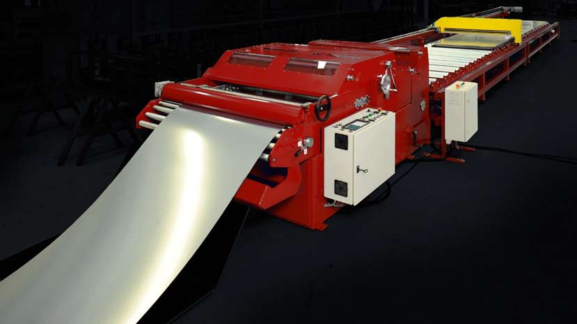

Teppolantie 4 FI-90440 Kempele Finland Tel. +358 8 5634 700 Fax +358 8 5208 752 [info@profiilikeskus.fi](mailto:info@profiilikeskus.fi) [www.profiilikeskus.fi](http://www.profiilikeskus.fi/)

## Re-coiler and Felt Brake

### Re-coiler

* Electrically operated
* With own control switches
* Forward and reverse operation
* Hydraulic expansion of mandrel with wedge mechanism
* With turned expansion plates 4 pcs
* Strip guides
* Hydraulic sheet gripper
* Equipped with separating discs and coil car

### Coil specification

##### Inner diameter

508 mm

##### Coil width

1250 mm, 1500 mm

##### Re-coiling capacity

5 to 10 tons

### Felt Brake

* + Strips go through the Felt Brake to the separating discs and re-coiler
  + Tightens up the strips while recoiling
  + Pneumatically operated
  + Braking force is adjusted manually

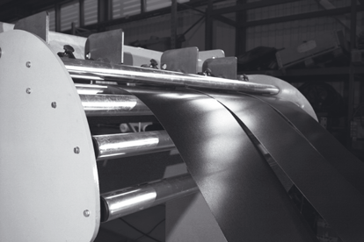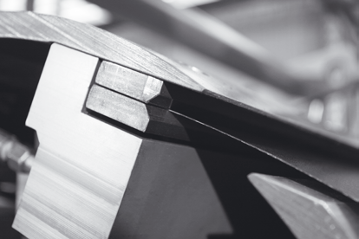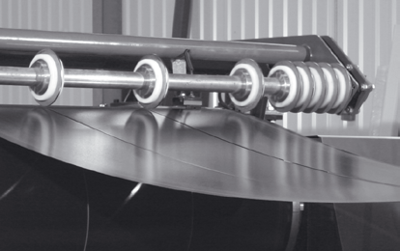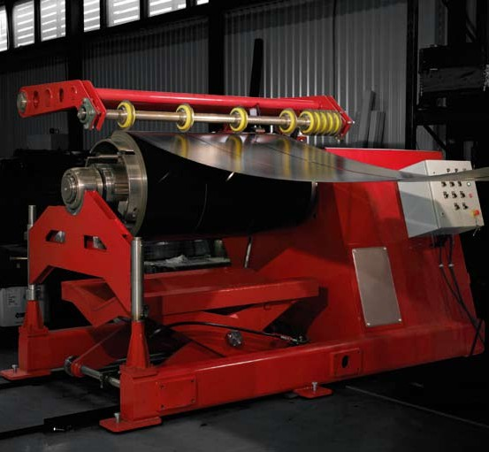

Teppolantie 4 FI-90440 Kempele Finland Tel. +358 8 5634 700 Fax +358 8 5208 752 [info@profiilikeskus.fi](mailto:info@profiilikeskus.fi) [www.profiilikeskus.fi](http://www.profiilikeskus.fi/)

#### Additional Equipment 21



# Additional Equipment

We are dedicated to designing and manufacturing both individual equipment and complete systems to fulfil the most demanding production requirements.

By combining various additional equipment from our wide range, the whole produc- tion process for machine constructions can be made as efficient and automated as possible. A reliable and powerful Decoiler is an essential part of fluent operation.

Our Decoilers are available in 5 to 15 ton coils to meet your exact requirements. From our large range of customized stackers you will easily find a solution that fits all the demands of your business and premises.

In addition, we manufacture and supply gutter and downspout machines as well as custom made rollformers for roofing accessories such as gable and straight cap flash- ing machines.

Please do not hesitate to ask about a rollformer to match your exact requirements. We have the solution!

Teppolantie 4 FI-90440 Kempele Finland Tel. +358 8 5634 700 Fax +358 8 5208 752 [info@profiilikeskus.fi](mailto:info@profiilikeskus.fi) [www.profiilikeskus.fi](http://www.profiilikeskus.fi/)

## Decoilers 5 to 15 tons

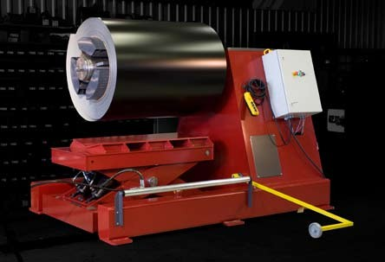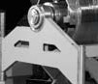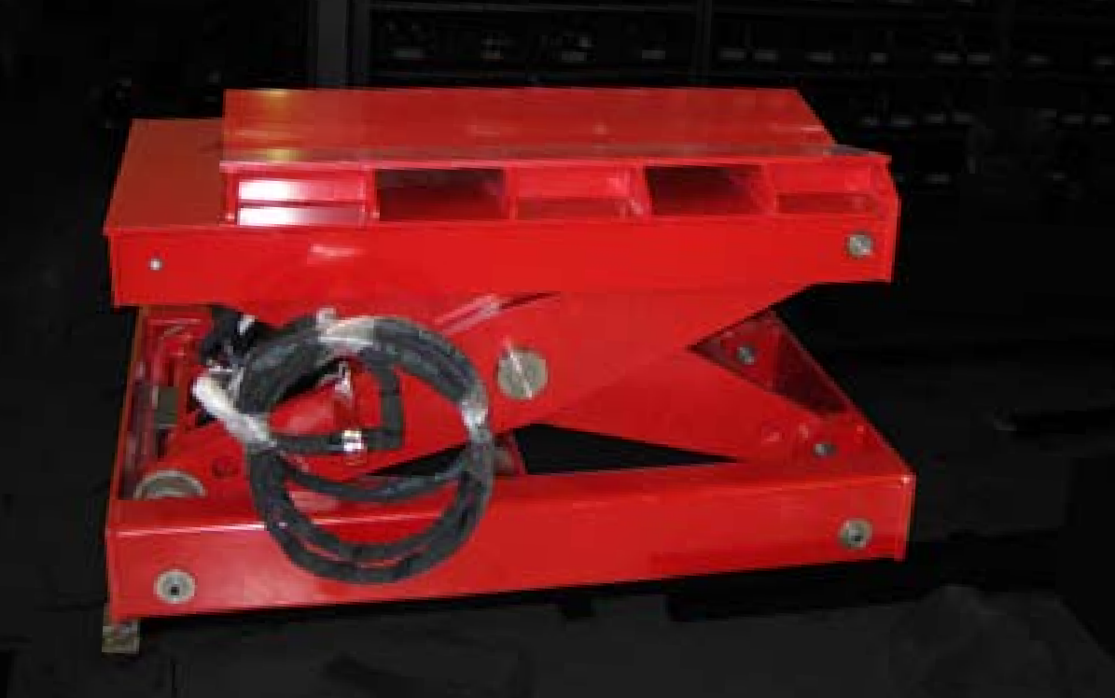

Decoilers are available for 5 to 15 ton coils. All of our Decoilers have forward and reverse functions. When operating automatically the decoiling speed is self-regulating and follows the speed of the rollforming line. Decoilers can also be equipped with wheels and placed on tracks to serve several machines.

### Electrically operated, 5 t

* + - Electrical wheeling
    - Mechanical tightening of coil
    - With front support

### Hydraulically operated, 7.5 to 15 t

* + - With own control switches
    - Hydraulic or electric wheeling, forward and reverse operation
    - Hydraulic expansion of mandrel with wedge mechanism

Decoilers for 12 to 15 t are equipped with front support

### Coil Car

The use of a Coil Car reduces changeover time when removing and replacing the coil.

* + Ascending and descending with two hydraulic cylinders
  + Lateral movement with one hydraulic working cylinder
  + Control switches located at de-coiler/re-coiler

##### Max. coil width

1500 mm

##### Coil weight

Available for 5 to 15 t coils

### Table of Decoilers

|  |  |  |  |  |  |
| --- | --- | --- | --- | --- | --- |
| **Decoilers** | **Inner diameter**  (mm) | **Max width of coil**  (mm) | **Max weight of coil**  (kg) | **Measures of decoiler**  (L x W x H mm) | **Weight**  (kg) |
| **Decoiler 15 t** | 490 - 610 | 1250, 1500 | 15000 | 2850 x 1700 x 1900 | 3000 |
| **Decoiler 12 t** | 490 - 610 | 1250, 1500 | 12000 | 2700 x 1600 x 1700 | 2700 |
| **Decoiler 10 t** | 490 - 610 | 1250, 1500 | 10000 | 2640 x 1550 x 1550 | 2200 |
| **Decoiler 8 t** | 490 - 610 | 1250 | 8000 | 2400 x 1550 x 1450 | 1800 |
| **Decoiler 7.5 t** | 490 - 610 | 1250 | 7500 | 2400 x 1500 x 1450 | 1800 |
| **Decoiler 5 t** | 490 - 610 | 1250 | 5000 | 2520 x 1250 x 1200 | 800 |

Decoiler measures with coil width 1250 mm

Teppolantie 4 FI-90440 Kempele Finland Tel. +358 8 5634 700 Fax +358 8 5208 752 [info@profiilikeskus.fi](mailto:info@profiilikeskus.fi) [www.profiilikeskus.fi](http://www.profiilikeskus.fi/)

## Stackers

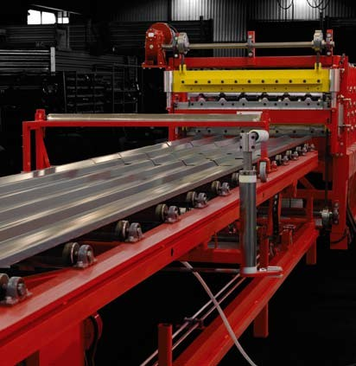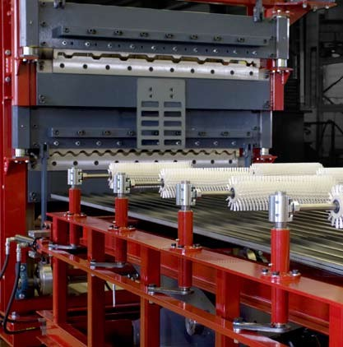

An automatic stacker completes the whole production process. The traditional Bomb stacker with a motorized rollerline is best suited to Tile sheet and Light-trapeze rollforming machinery. As the sheet exits the rollformer it slides along the stacker wings. And when the sheet is cut it drops freely onto the rollerline. The sheets are always even from one end and there is pneumatically operated pusher to slightly push every sheet to be align.

The optimum stacking system for our Heavy duty rollformin machinery is the Stacker with a sheet trolley and rollerline. The trolley moves with a sheet and slides from under the sheet after it has been cut and returns to receive the following sheet. On the rollerline there are pneumatically operated support rolls to support the sheet from underneath keeping it straight. After the sheet is cut they turn back to homeposition. Now the stack is easy to remove from the rollerline since it is fully accessible from above.

One of our latest innovations – a stacker with cushioning brushes – is the perfect solu- tion for protecting the sensitive sheet coatings when sheets are driven colour-side down. The cushioning brushes ensure a scratch-free finish for every sheet of a stack. The stacker frame consists of a dual structure, where the inner part is driven with hydraulic jacks. When the stack is complete, the inner part of the stacker is raised above all the other structures including the cushioning brushes. This leaves the stack fully- and safely-accessible from both above and the sides.

We also supply various tailored stacking systems, for example for weight centered stacks.

Teppolantie 4 FI-90440 Kempele Finland Tel. +358 8 5634 700 Fax +358 8 5208 752 [info@profiilikeskus.fi](mailto:info@profiilikeskus.fi) [www.profiilikeskus.fi](http://www.profiilikeskus.fi/)

## Wrapping Machine



Teppolantie 4 FI-90440 Kempele Finland Tel. +358 8 5634 700 Fax +358 8 5208 752 [info@profiilikeskus.fi](mailto:info@profiilikeskus.fi) [www.profiilikeskus.fi](http://www.profiilikeskus.fi/)

Profiilikeskus Wrapping machine is designed and manufactured for easy wrapping of the stack with plastic film. Just lift the stack onto the conveyor and turn on the line.

The entry conveyor drives the bundle through the wrapping unit and exit conveyor receives it after wrapping. The whole process is automated.

The number of plastic film layers is regulated by adjusting the speed of the wrapping unit. The speed of the conveyors is always set. Speed up the wrapping machine and there will be thicker layer of plastic or slow it down and you’ll have the stack with thin plastic wrapping.

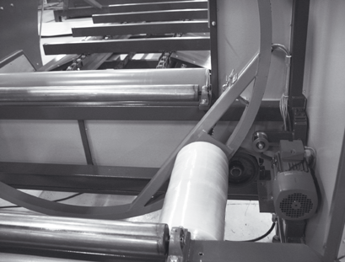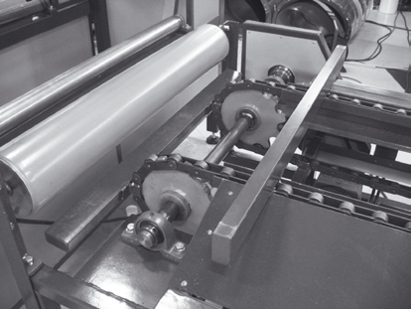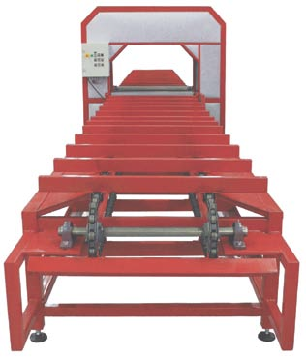

##### Tunnel dimensions

Ø 800 mm

Ø 1300 mm

**Electrically operated Double roll of stretch fllm Soft Start-up**

**Stepless speed control**

### Ø 800 mm

##### Film width

300 mm

##### Electrical conveyors

3.5 + 3.5 m

##### Maximum packet size

700/700 mm

##### Minimum wrapping length

1000 mm

##### Max load

250 kg/m

### Ø 1300 mm

##### Film width

500 mm

##### Electrical conveyors

6 + 8 m

##### Maximum packet size

1200/500 mm or 1000/700 mm

##### Minimum wrapping length

2000 mm

##### Max load

500 kg/m

## Downspout and Elbow Machine

### Automated Downspout Rollforming Made Available to Everyone

The inventive design combines downspout and elbow forming functions into one compact rollformer which allows efficient, automated downspout rollforming to anyone.

### Specification

##### Automation

* Easy to use programming - the diagram of a product is shown on the screen
* Register for 100 standard products
* Programming is available in millimeters or inches

##### A synchronized crimping tool can be turned on or off as needed

**Model of the pipe**

Round

###### Size of the pipe

87 mm, 100 mm and 125 mm

##### Material thickness

* + Steel 0.40–0.50 mm
  + Aluminium 0.57–0.81 mm
  + Copper 16 oz

##### Width of strip

292–416 mm ±2 mm

##### Speed

20 meters / minute or 350 elbows / hour

##### Drive with servomotor

4.4 kW, 3 x 400 V, 50 / 60Hz

##### Hydraulic cutting and crimping

4 kW / 125 bar

##### Machine dimensions

* Length 9000 to 11000 mm
* Width 900 mm
* Working height 1000 mm
* Weight average 4000 kg

##### Chemically treated rollers to inhibit corrosion

## Gutter Machines

### Electrically operated

##### Model of the gutter

Half-round or angular

##### Available in sizes

125 and 150 mm (5” and 6”)

##### Material thickness

* + Steel 0.40 – 0.50 mm
  + Aluminium 0.57 – 0.81 mm
  + Copper 16 oz

##### Strip width

298 – 381 mm

##### Speed

10 meters / minute

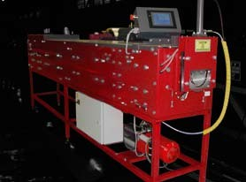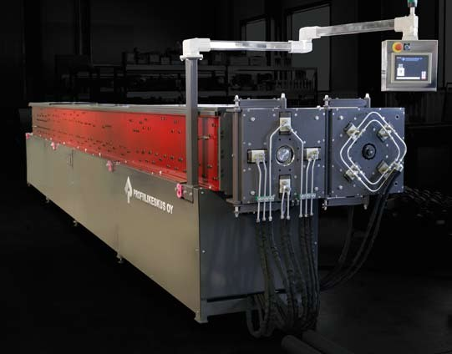

Teppolantie 4 FI-90440 Kempele Finland Tel. +358 8 5634 700 Fax +358 8 5208 752 [info@profiilikeskus.fi](mailto:info@profiilikeskus.fi) [www.profiilikeskus.fi](http://www.profiilikeskus.fi/)

## Customised Rollformers for Narrow Roofing and Cladding Profiles and Accessories

When the production volume of flashings is high, it is more productive and profitable to rollform the flashings instead of using a bending machine to manufacture them.

Our Gable and Straight cap flashing rollformers are electri- cally operated. Carefully designed forming rolls are fine- turned and furnaced, which produces a hard, smooth and easy-to-clean surface.

Depending on the profile, the post-cutter can either be electric or hydraulic. When the profile needs punching we equip the machine with the most modern punching tech- nology and appropriate dies.

Our rollforming machines are easy to control, using either manual or automatic drive. After entering the length and number of pieces, just press the autodrive button and the rollformer does the rest.

In addition, we also design and manufacture machines for rollforming unique roofing and cladding profiles from nar- row strip.

Our conveniently-sized decoilers for narrow strip completes the fully-automated process. Decoilers are available for strips of width 300 mm, 400 mm and 600 mm and for coil weights of either 700 kg or 1500 kg.

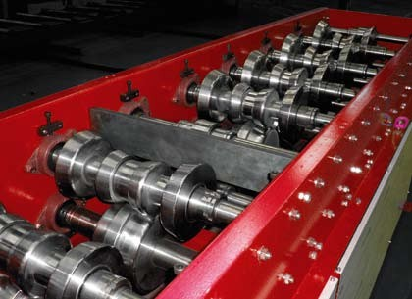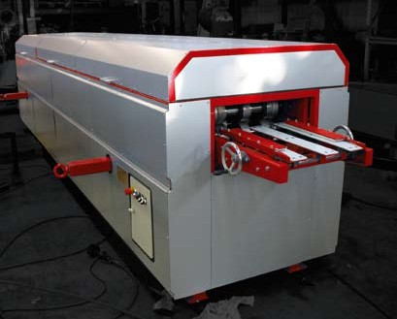

### Material requirements

##### Thickness

0.45 mm -1.0 mm

##### Width of strip

100 to 600 mm

###### For coated and/or galvanized steel Rolling speed 20 m/min

Teppolantie 4 FI-90440 Kempele Finland Tel. +358 8 5634 700 Fax +358 8 5208 752 [info@profiilikeskus.fi](mailto:info@profiilikeskus.fi) [www.profiilikeskus.fi](http://www.profiilikeskus.fi/)

When production volume is high, it becomes more profit- able to rollform the flashings instead of using a bending machine. Profiilikeskus offers carefully designed rollformers

e.g. for Gable and Straight Cap flashings. In addition, we design and manufacture machines for rollforming unique roofing and cladding profiles from narrow strip.

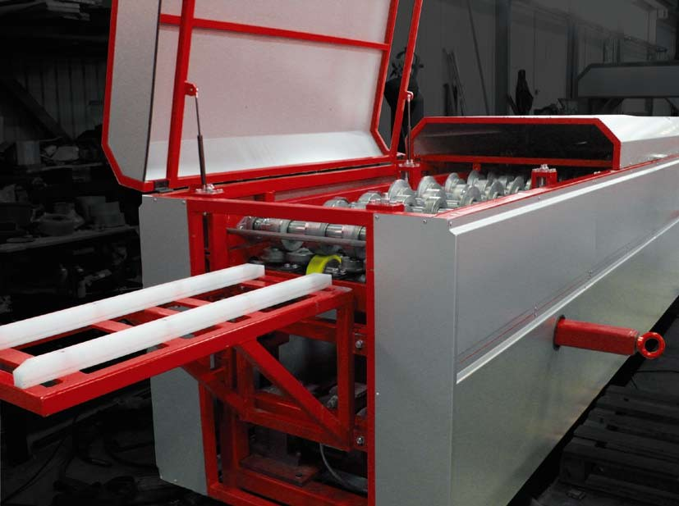

100 ± 2

100 ± 3



Teppolantie 4 FI-90440 Kempele Finland Tel. +358 8 5634 700 Fax +358 8 5208 752 [info@profiilikeskus.fi](mailto:info@profiilikeskus.fi) [www.profiilikeskus.fi](http://www.profiilikeskus.fi/)

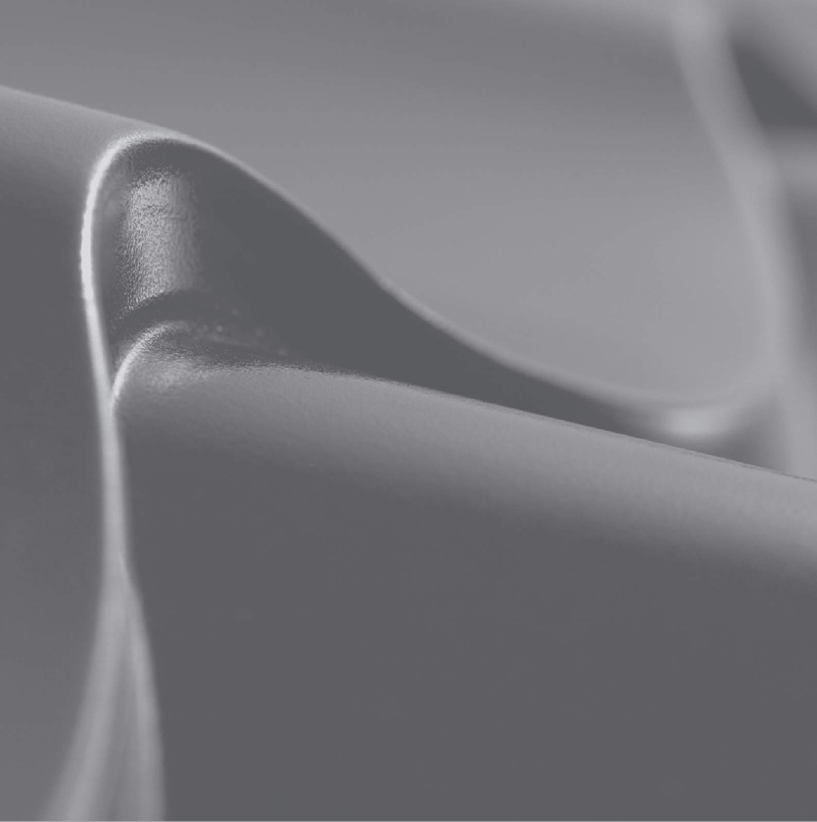

##### Proflilikeskus Oy

Teppolantie 4

FI-90440 Kempele Finland

Tel. +358 8 5634 700

Fax +358 8 5208 752

[info@profiilikeskus.fi](mailto:info@profiilikeskus.fi)

[**www.proflilikeskus.fl**](http://www.proflilikeskus.fl/)